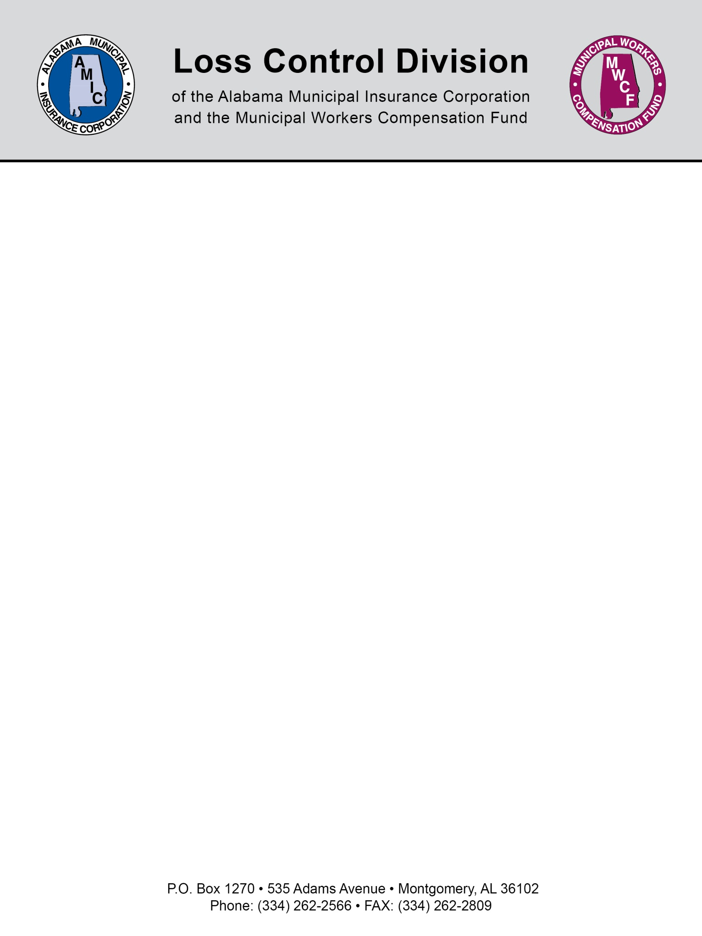

Sample Vehicle Use Form

Only authorized employees assigned to a City vehicle are permitted to operate City vehicles. City vehicles are not for personal use. Only City employees are allowed in City vehicles unless the employee’s job description allows otherwise, such as police and emergency vehicles. Occupants of all City vehicles must adhere to the state seat belt law during use of all City owned vehicles.

UNAUTHORIZED PASSENGERS IN CITY VEHICLES ARE PROHIBITED
The City/City’s insurance company will not be held responsible for any damages suffered by an unauthorized passenger, including personal injury, property damage, loss of property, or death.
As part of the City’s safety policy, employees’ personal driving habits, on or off duty, can affect his/her employment status. Serious driving violations can result in demotion, reclassification or termination.

I certify by signing below that I full understand and agree to abide by this policy.

______________________________________ _____________________
SIGNATURE DATE

______________________________________
HR/RISK MANAGER

NOTE: This document is not intended to be legal advice. It does not identify all the issues surrounding the particular topic. Public agencies are encouraged to review their procedures with an expert or an attorney who is knowledgeable about the topic. Reliance on this information is at the sole risk of the user.
Rev 1/2014

